MCP – Model Context Protocol

Classroom First Session:
Use VSCode
Classroom Activity - 1
1. Go to extensions
2. Type @mcp Playwright
3. Intall the plugin from Official(Microsoft)
4.MCP Servers - Installed -- Playwtight
5. Click on Settings icon -- Start Server(Confirm the console for 24 tools are running)
6. Open copilot - Agent Mode
7. go to https://leaftaps.com/opentaps/
login with credentials: democsr/crmsfa
click on logout and close browser
8. Confirm the test cases is executed.
9. Explore the Json
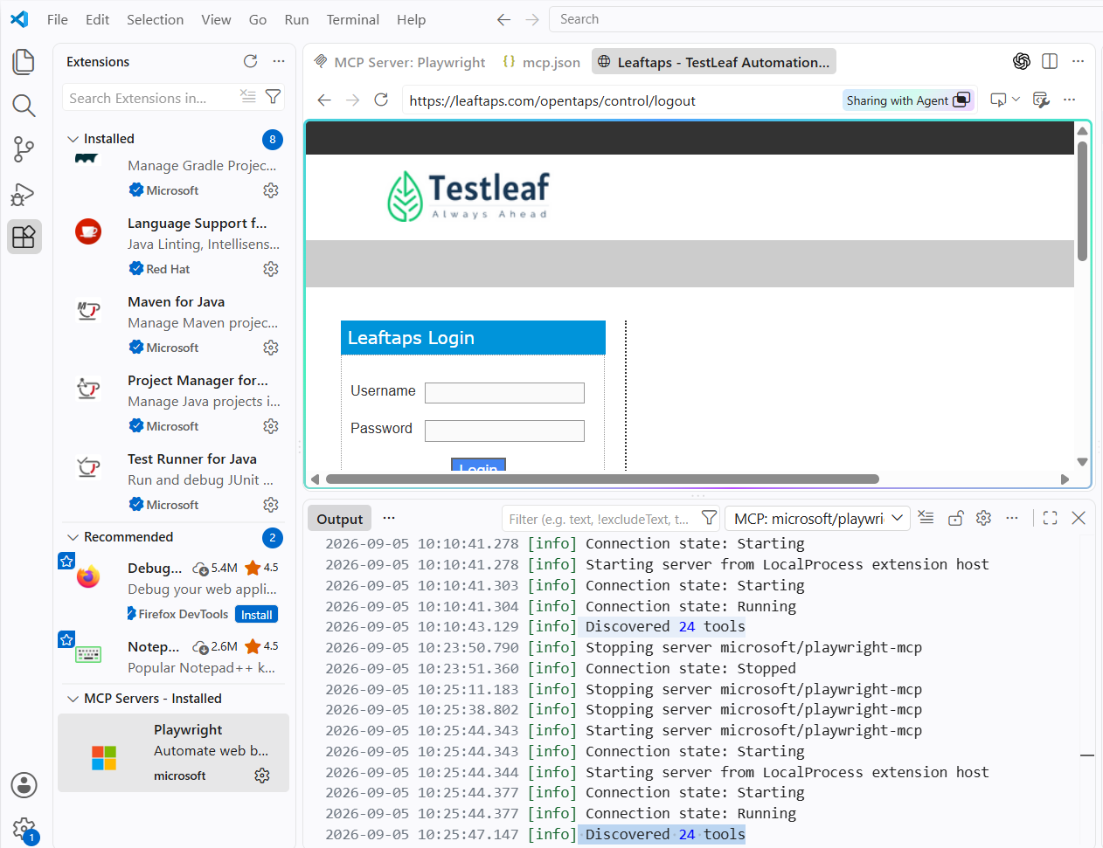

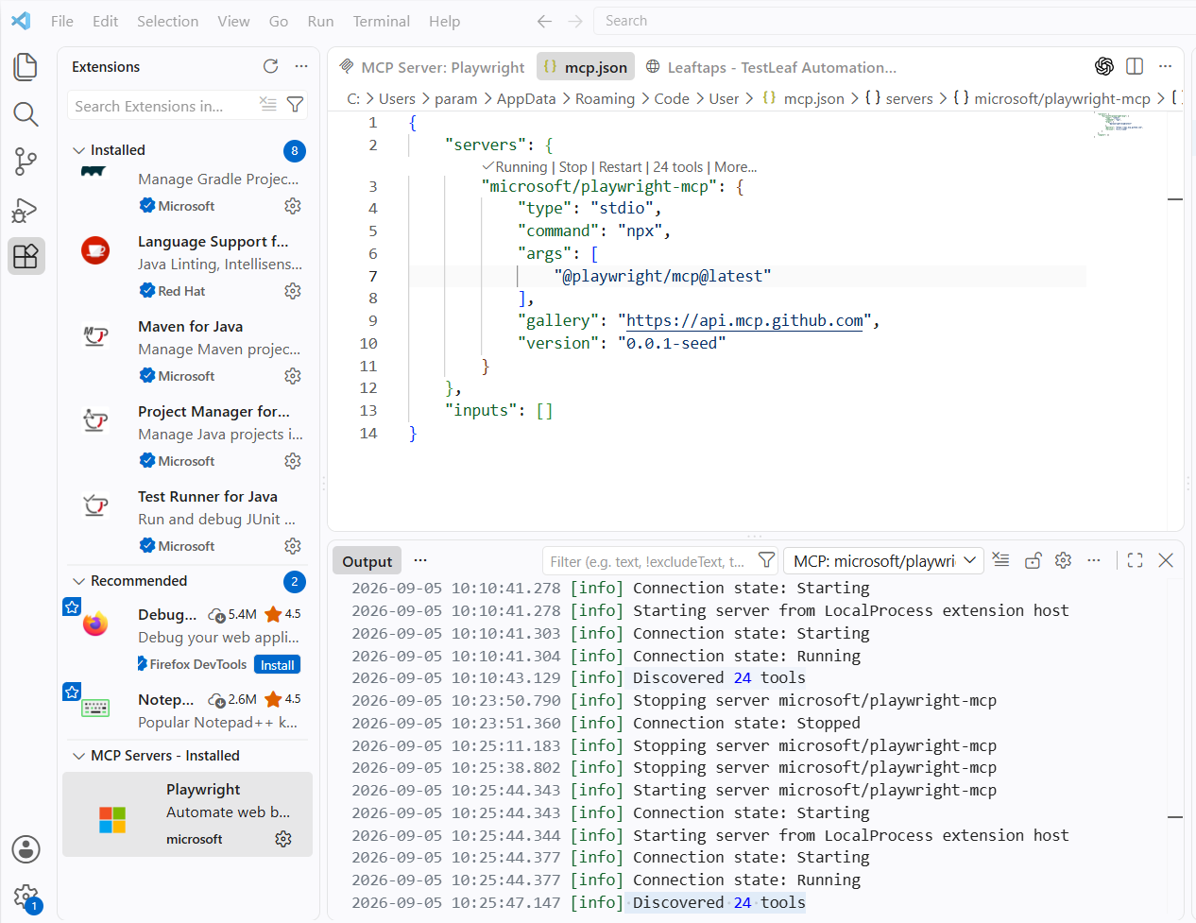

Classroom Second Session:
1. Open the terminal, and run below commands:

npm install -D @playwright/test
npx playwright install
npx playwright init-agents --loop=vscode

2. you can see "playwright-test" extension
3. Click on setitngs and start server(89 tools)
4. Take any sample website like amazon search or google search
5. Using planner agent genrate test scenarios.md file using planner agent in in copilot
6. Try Atlear for one test sceanrio(context md file), generate script using Generator agent in copilot
7. Fail the test case(change the locator)(Keep the failed test open)-- use healer in copilot and fix it

playwright-test created
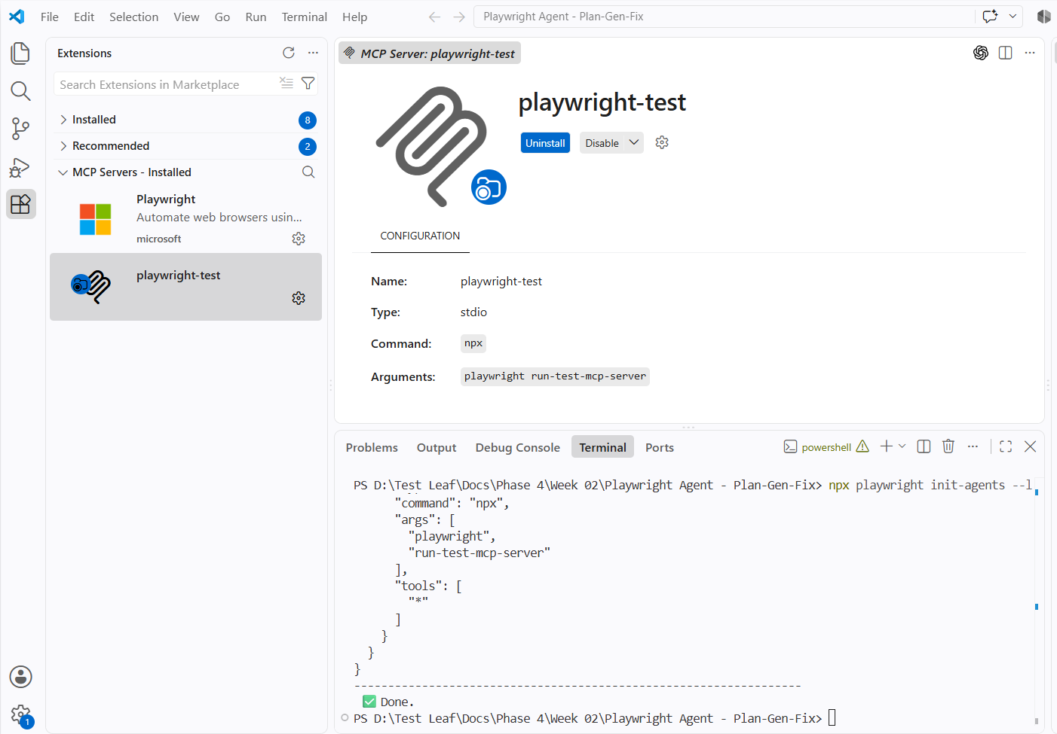

Started the server
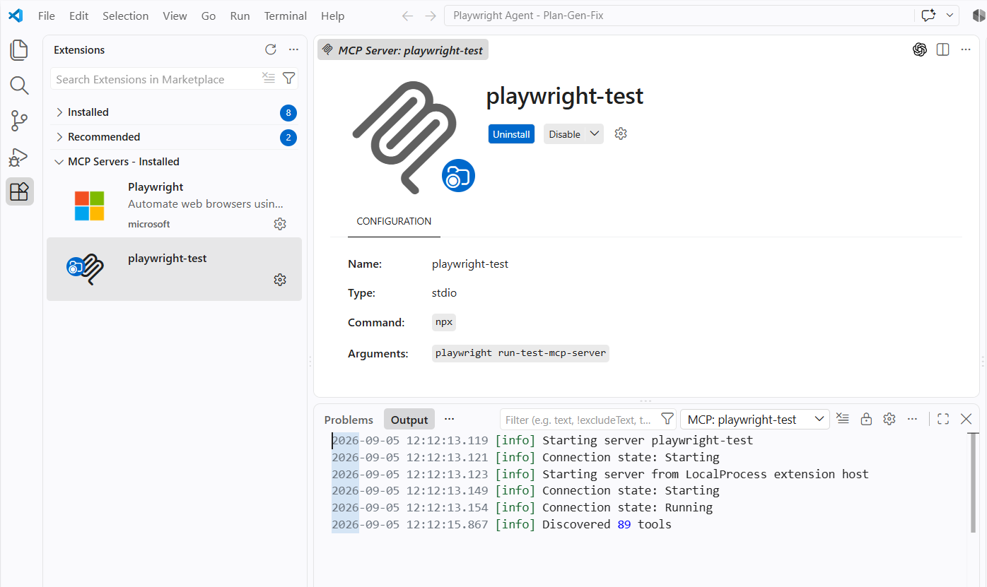

Test Planner
Prompt:
Generate a test cases for the below scenario.
Goto Google.com
Search for "this week ott release"
File Generated:
google-ott-release-search.plan.md got created
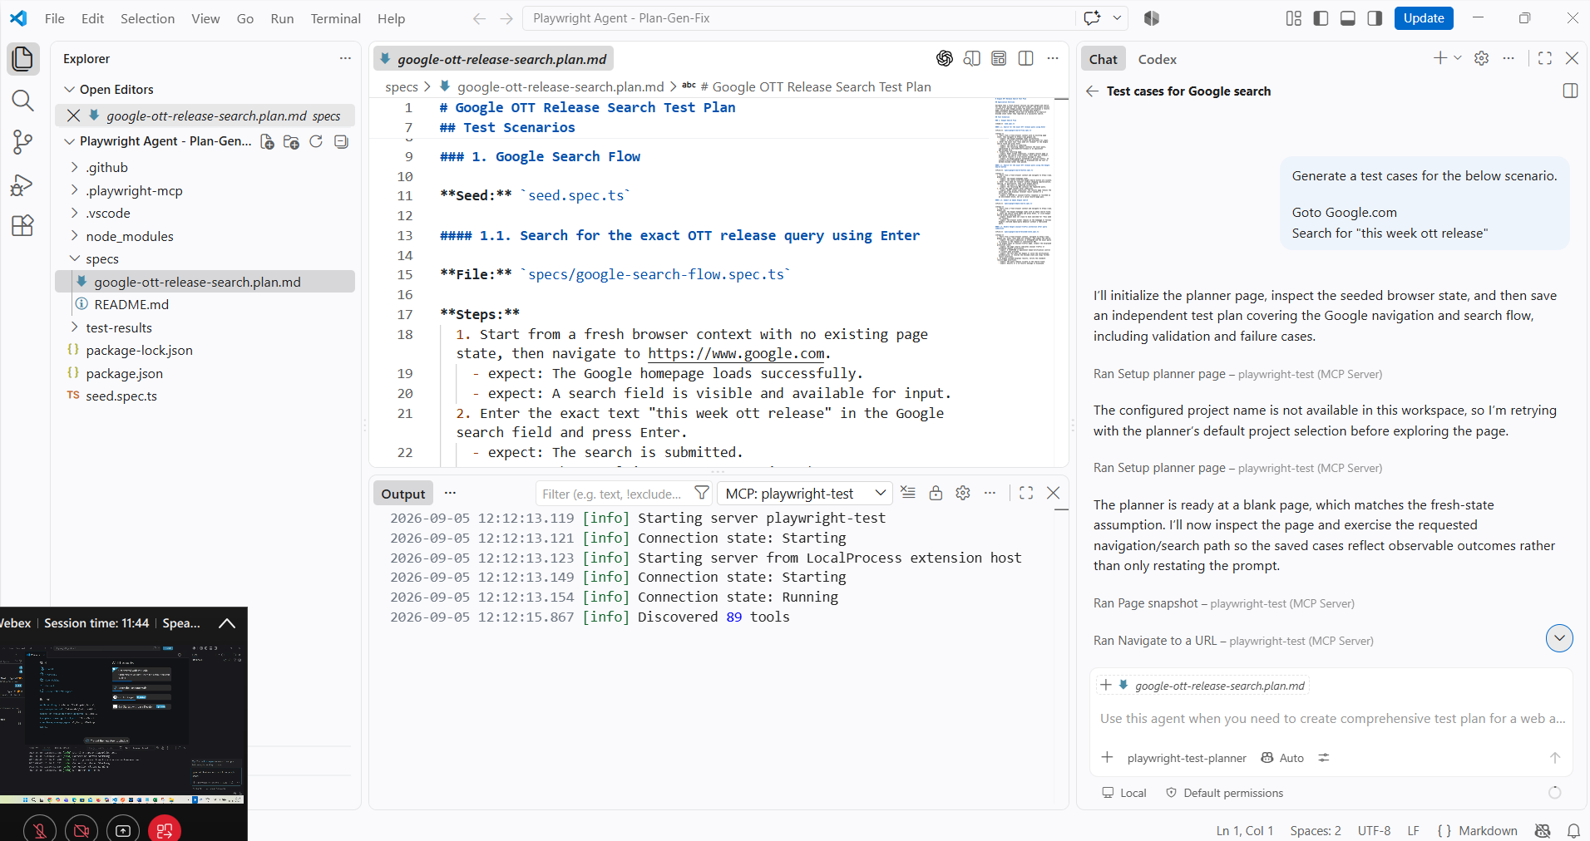

Test Generator
With this file execute the test case and generate the playwright script
google-ott-release-search.plan.md
Prompt:
Generate the test case and script for the below scenario
#### 1.1. Search for the exact OTT release query using Enter
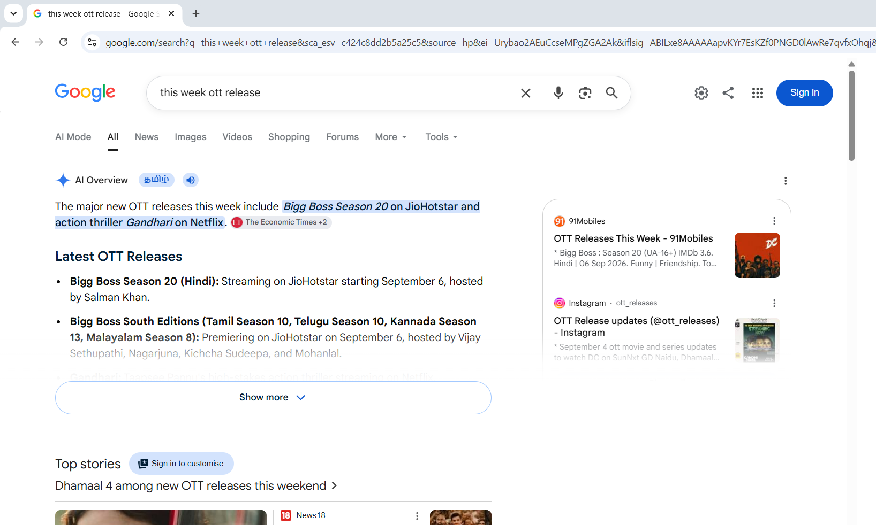
Generate the scripts google-search-flow.spec.ts
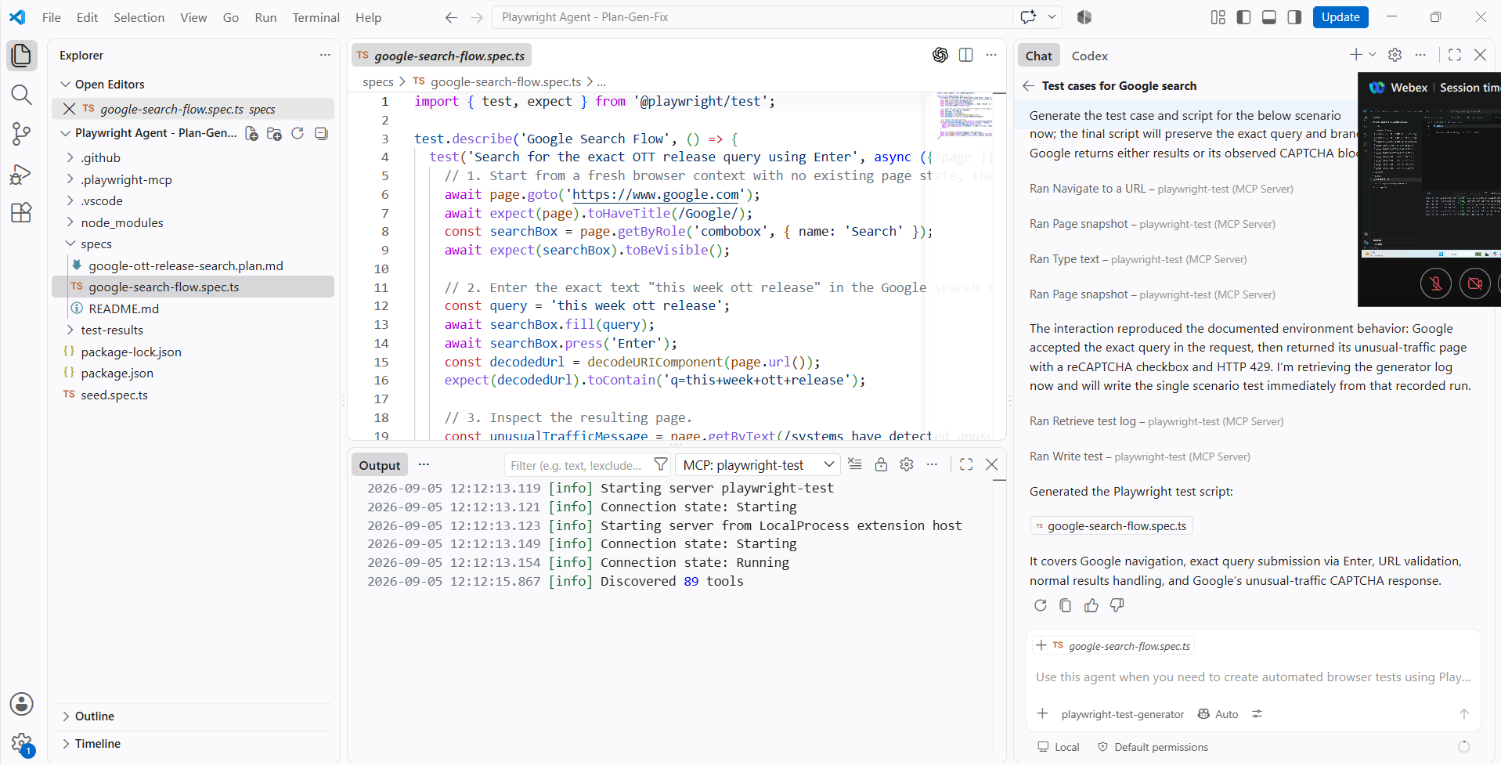

Test Fix
Prompt:
Run this script and fix any error occurred
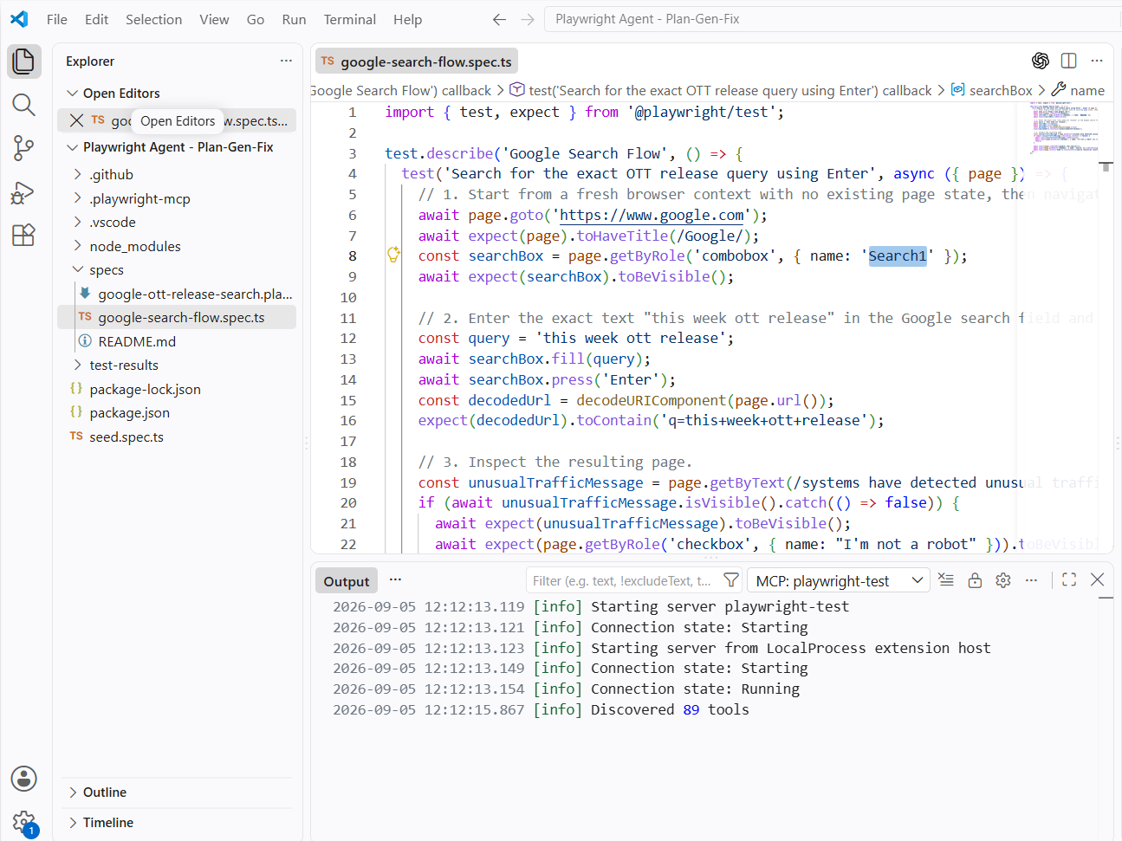
It found the issue “Search1” and changing it into “Search”
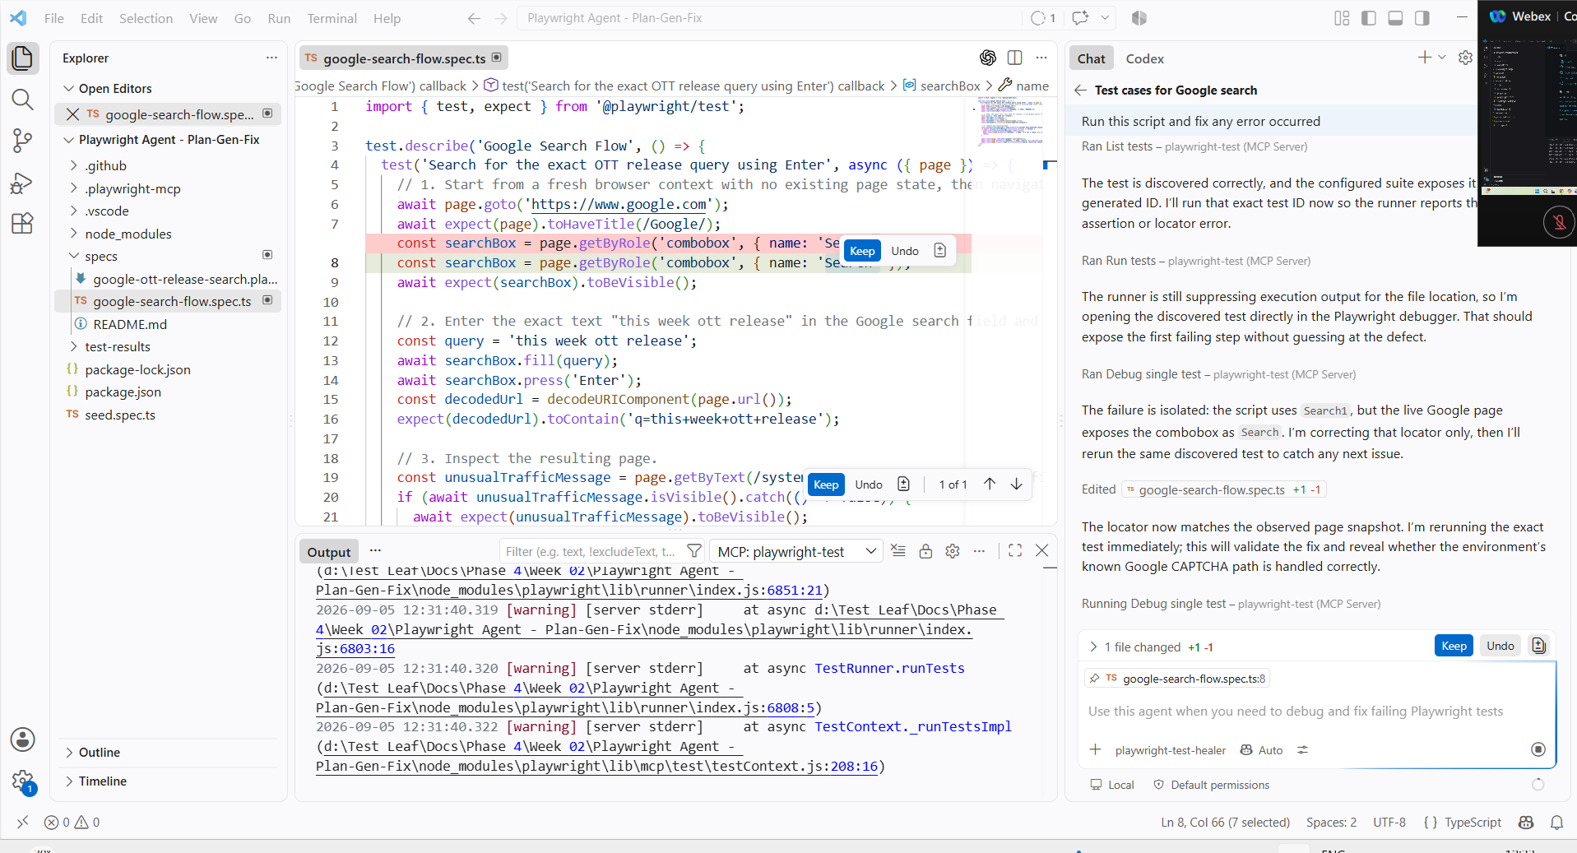

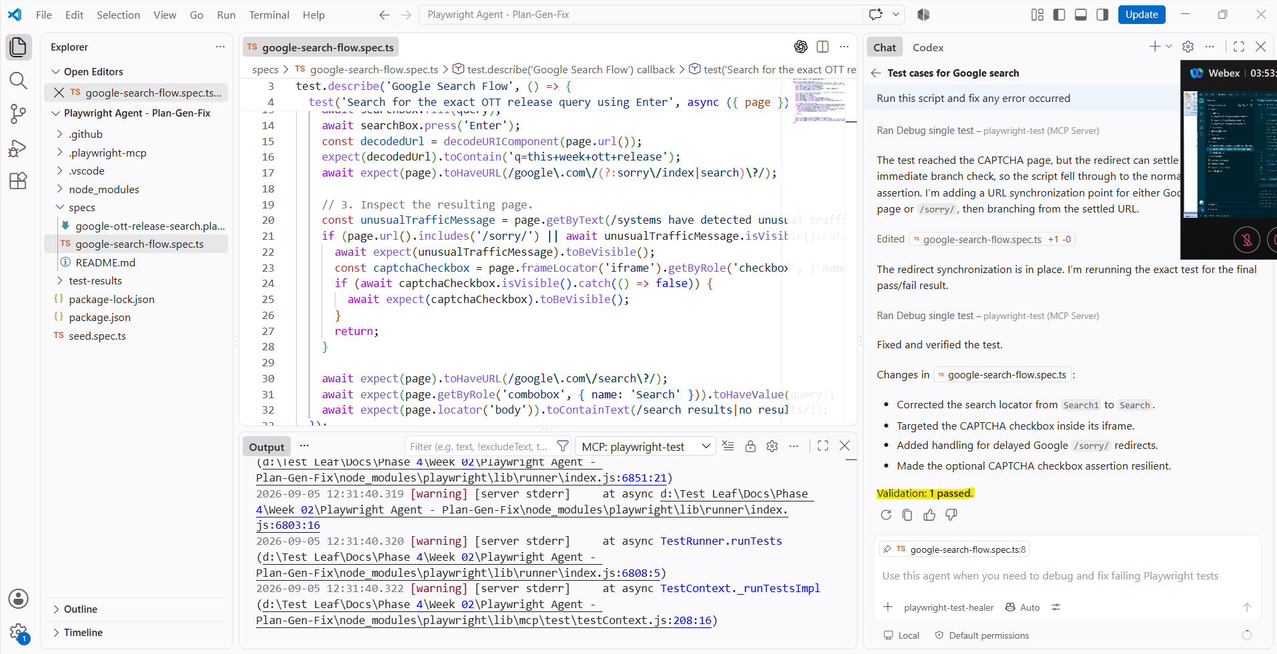

Assignments – Day 01
# Homework Assignment
Sonic Framework
*Task:* Update the Playwright Generator Agent prompt to generate test scripts according to the given framework format.

Please find the Playwright framework provided below. The agent prompt should be updated to ensure that the generated test scripts strictly follow the structure, conventions, and standards defined in the framework.

Test Case Planner
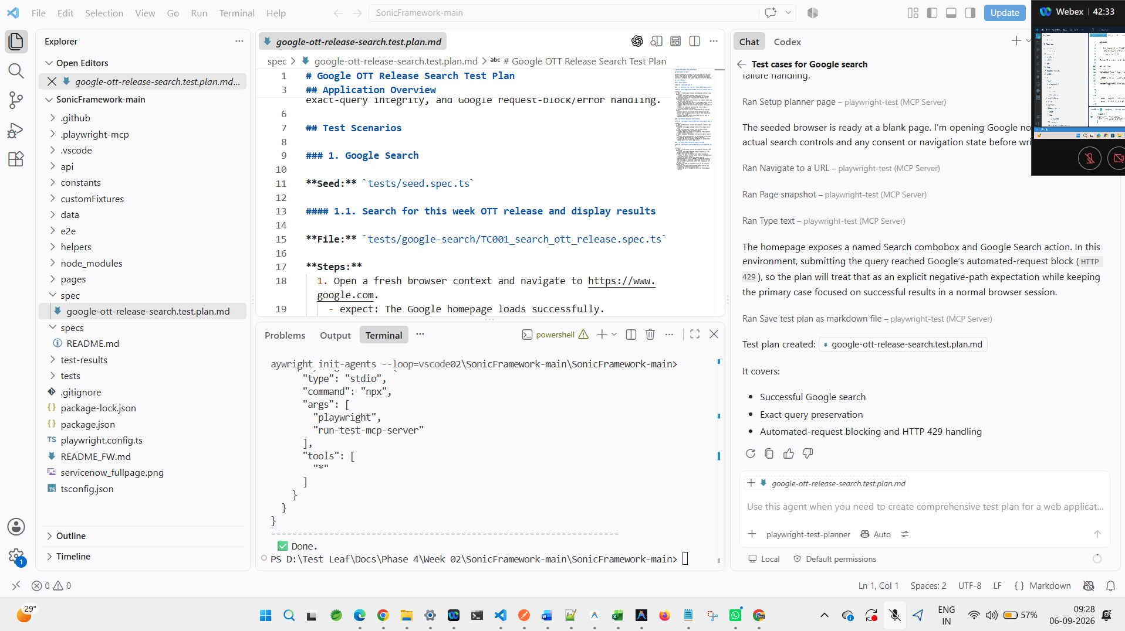

Test case Generator
Generate the test case and script for the below scenario
#### 1.1. Search for the exact OTT release query using Enter
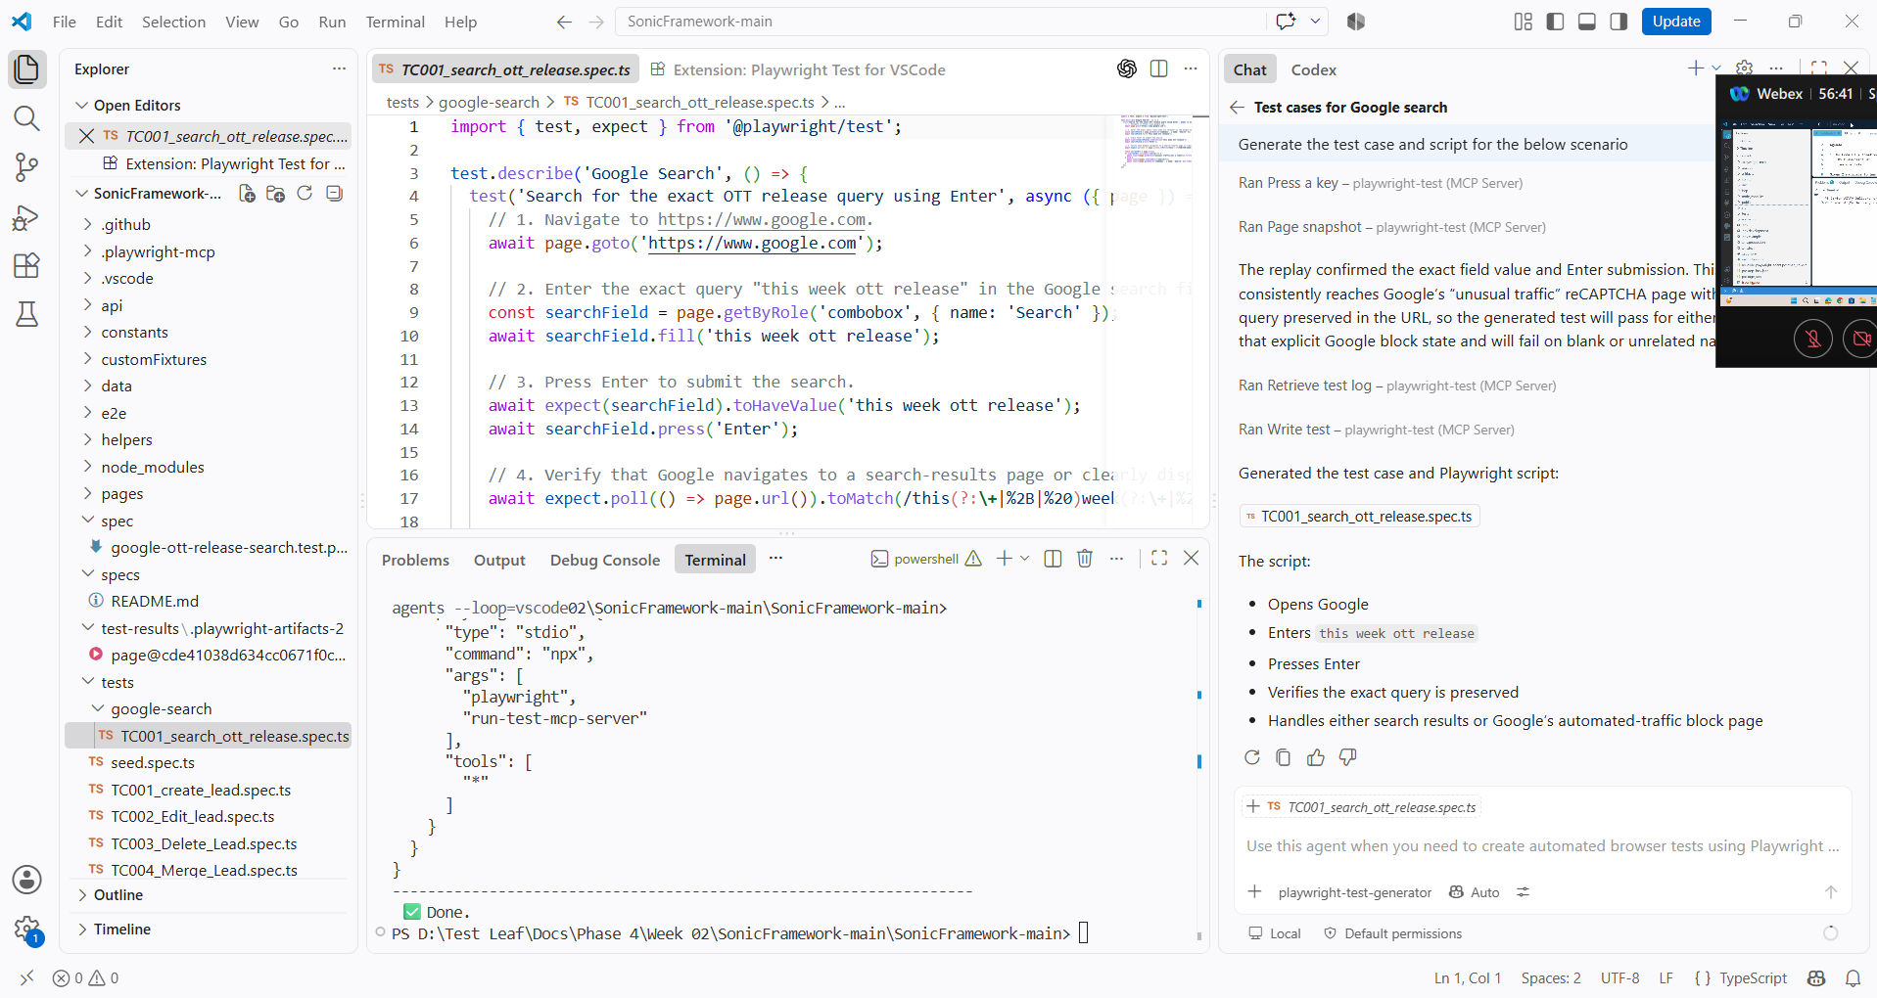

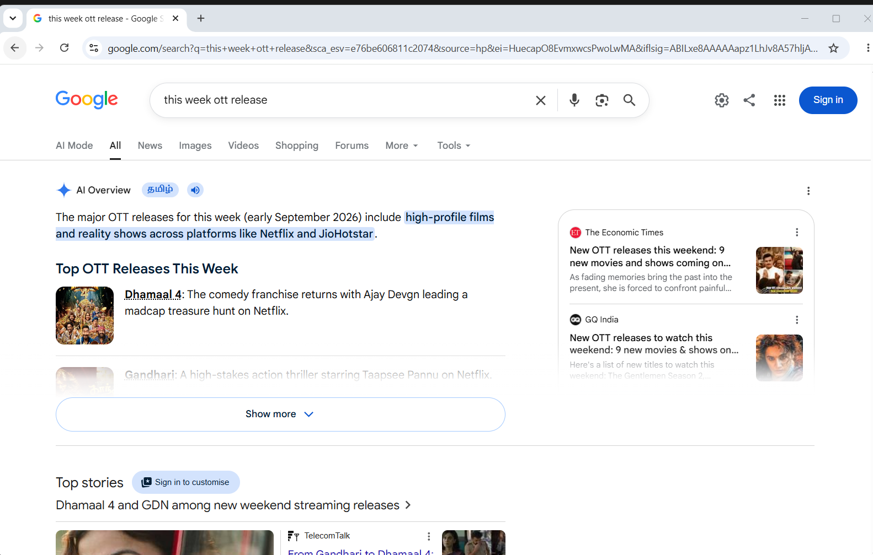

Day 02 – ClassRoom Activity
1. Unzip the code
2. Env file -- update your groq key/model
3. From root folder (no-code) <--Backend
npm install
npm run dev
3. Open the terminal in "web-app" folder <-- frontend
npm install
npm run dev

Run the below feature :
Feature: Sample Login Test
As a user
I want to login to the application
So that I can access my account

@smoke @login
Scenario: Successful login with valid credentials
Given I navigate to Leaftaps application
When I enter Username as "Democsr2"
And I enter Password as "crmsfa"
And I click the login button
